Team members: Travis Carlson, Zachary Walker, Michael Hager, Locke Lehmann,

MEEN 402-500 Bray Team

**DFX Lecture Assignment**

1. What features in your design accounted for Dfx principles?

The two deliverables we have, which are the measurements for valve position and actuator torque, were requested by Bray to be independent of the other component. The solution for the position of the valve is independent of the actuator, and vice versa. This incorporates Design for Assembly principles by making the design of the valve-actuator system very modular, meaning that we don’t have to rely on one component to manufacture the other one. Keeping the component solutions fully embedded into their respective components allows for easier manufacture, removing the possible complexity of having to adjust the valve position solution for different sizes of actuator, or vice versa. Additionally, the two solutions we have implemented so far (the strain gauges for the actuator and the potentiometer for the position), only require one additional hole each to be drilled into the valve and actuator. So if Bray would like to keep their manufacturing process the same, they can simply add an extra step at the end of their assembly line for sensor addition, minimizing the disruption to their building of these parts. This factor of the project considers Design for Manufacturing by considering the possible implications of the sensor solutions if Bray does decide to mass-produce them and add them to their products. They can also retrofit the sensors onto existing products fairly easily, rather than undergoing a complete rebuild. The images below show the different valves and actuators that Bray sent us, the position manufacturing process (on the mill), and the strain gauge insertion into the actuator stop bolt.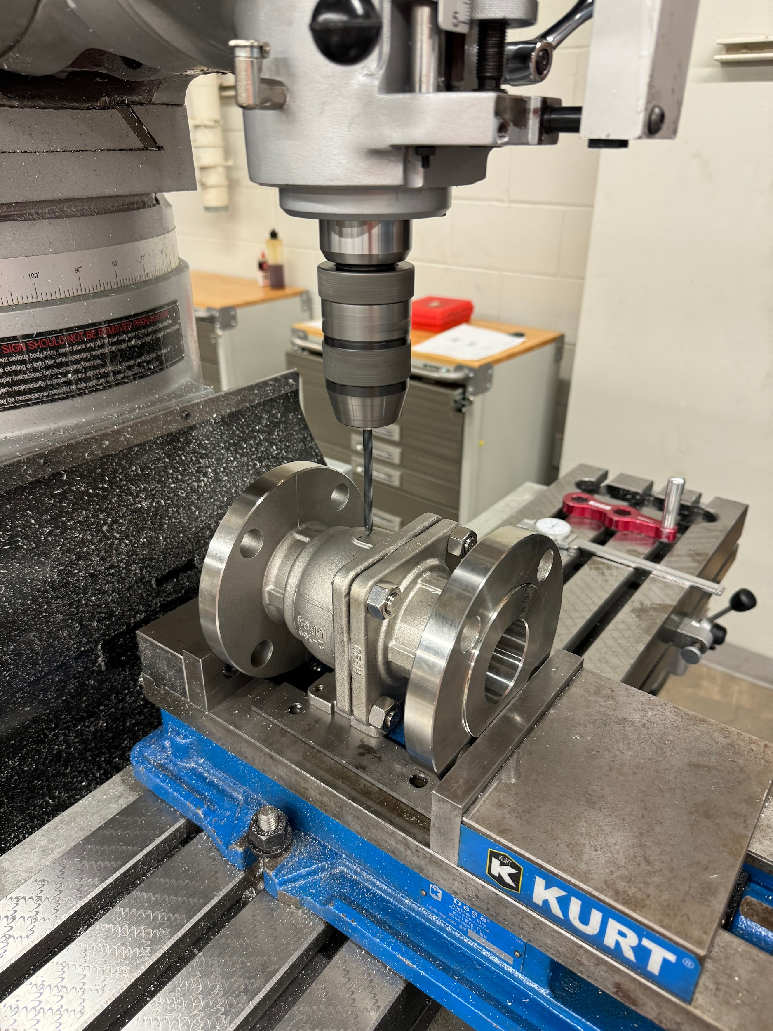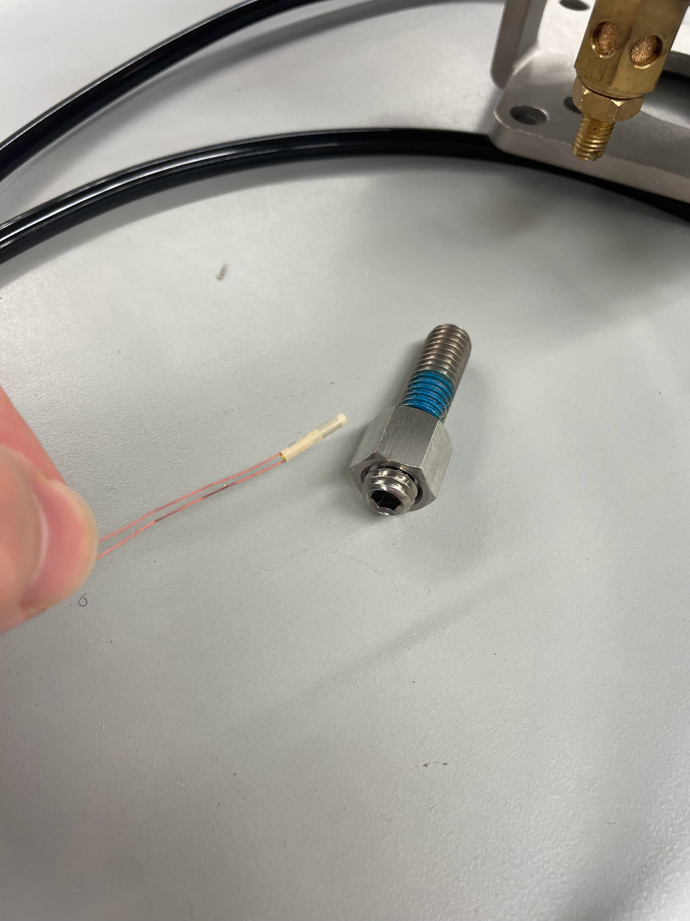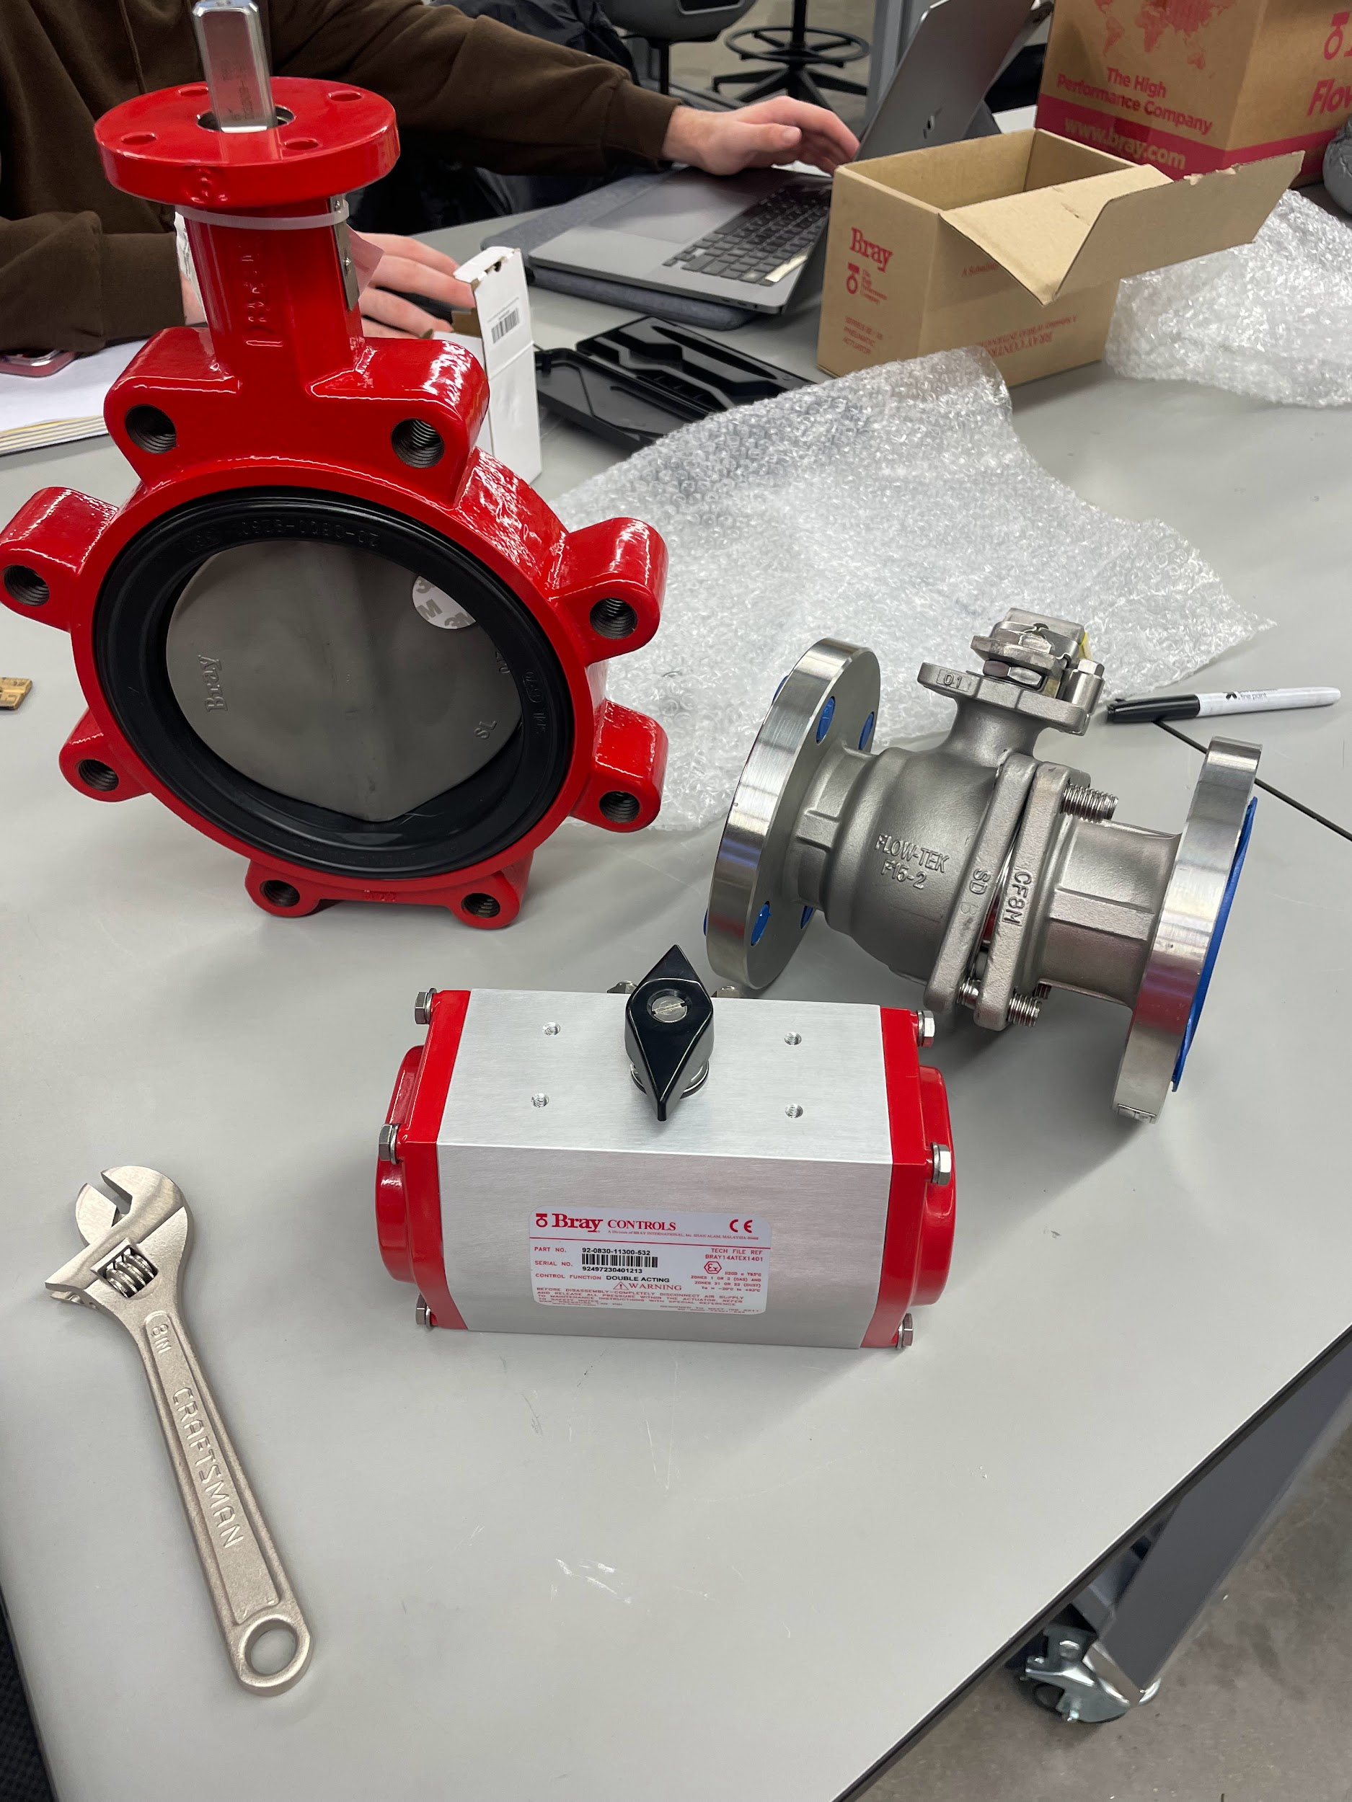

1. What features could be added/updated to account for Dfx principles?

We could investigate a way to send the data from these sensors wirelessly rather than using wired connections to a Raspberry Pi. Right now we are using a wired DAQ, but making the data transmission wireless would help to more easily move the components around and not have to worry about connecting and disconnecting wire when assembling a valve-actuator system, which would create easier assembly (Design for Assembly) for Bray’s customers. Additionally, it would make the system easier to assemble if perhaps the sensor system could be manufactured separately, or perhaps just the DAQ made separately, and then it could connect to the valve-actuator system with the sensors installed. Right now it is a little delicate to set up all the components and connect them all to the DAQ, but making this connection simpler to implement would help Bray’s customers assemble their parts more easily.